**Assignment No:-51**

Name:-Suryawanshi Sangramsingh Sambhaji

Batch: - Delta - DCA (Java) 2024 Date:-23/7/2024

**1. Write a Java program to associate the specified value with the specified key in a Tree Map.**

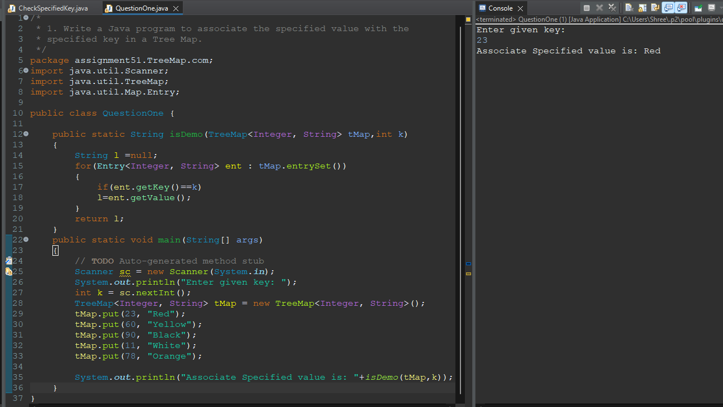

**2. Write a Java program to copy Tree Map's content to another Tree Map.**

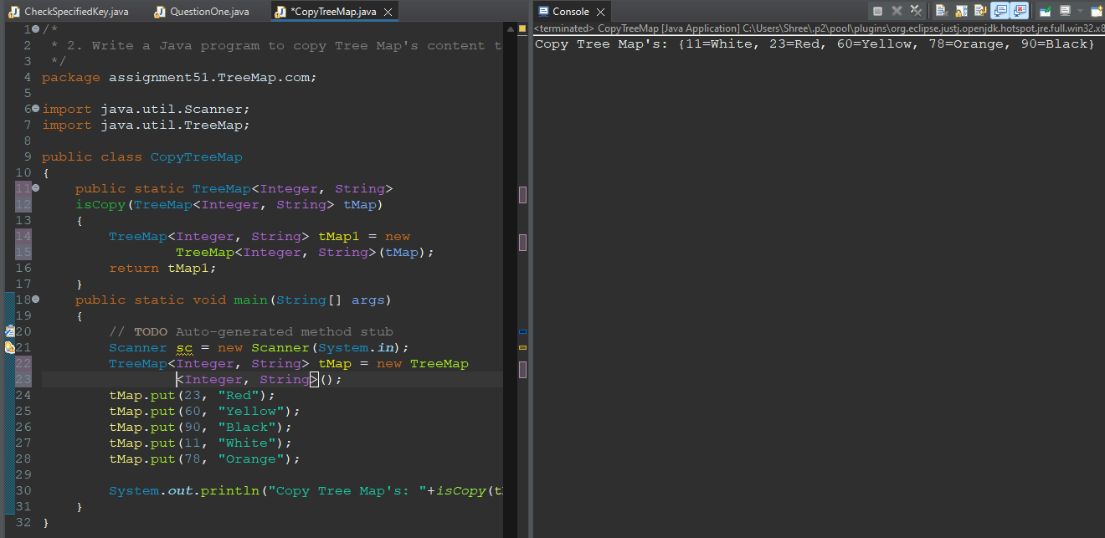

**3. Write a Java program to search for a key in a Tree Map.**

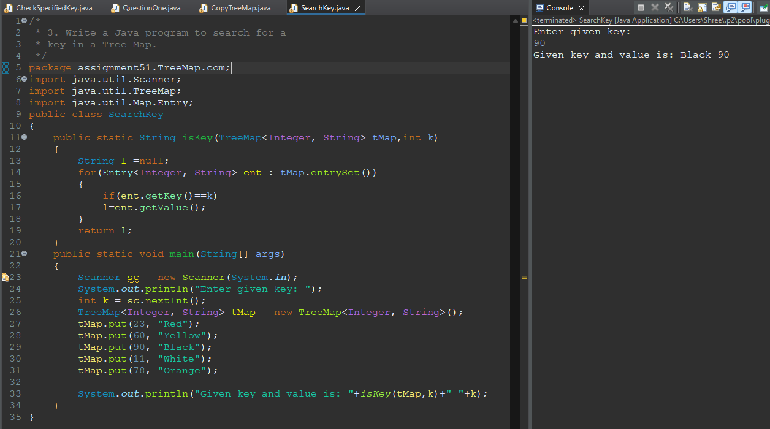

**4. Write a Java program to search for a value in a Tree Map.**

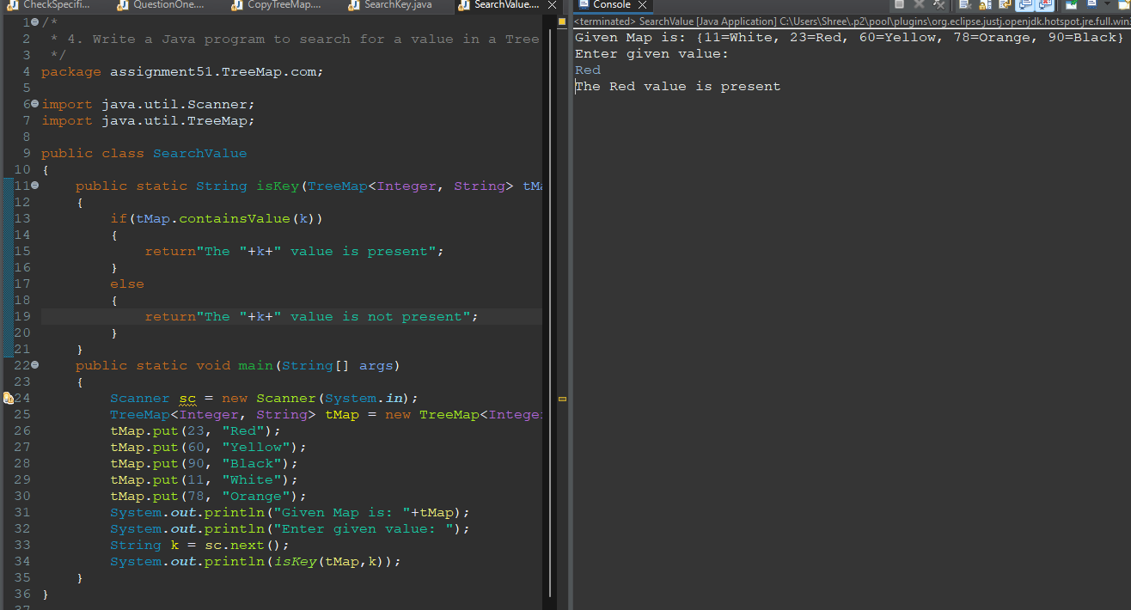

**5. Write a Java program to get all keys from a Tree Map.**

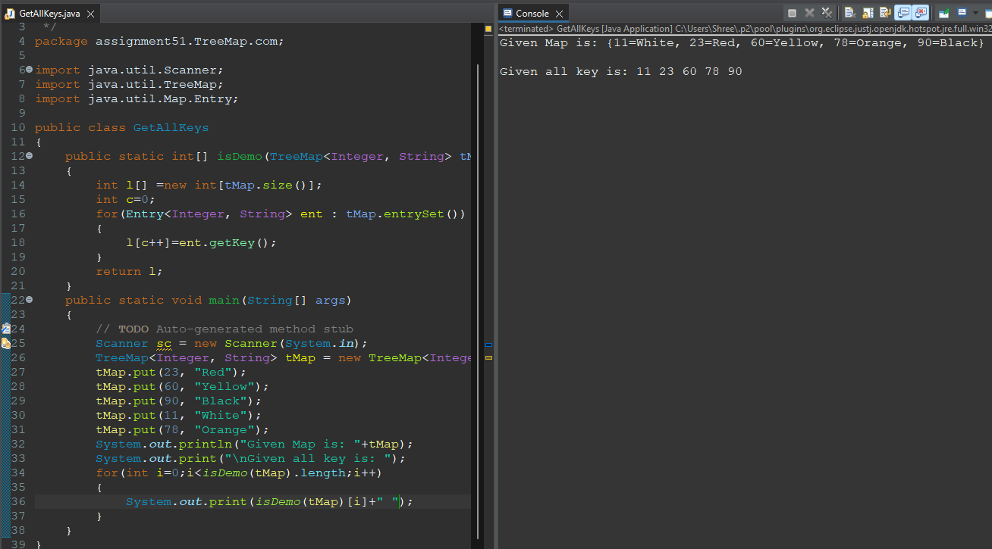

**6. Write a Java program to delete all elements from a Tree Map.**

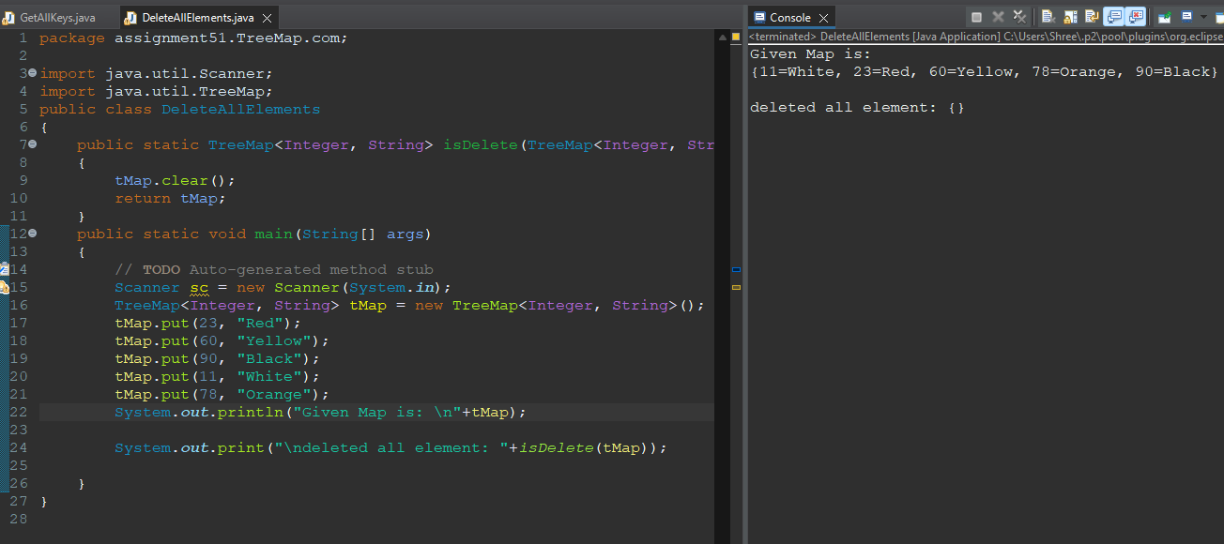

**7. Write a Java program to sort keys in a Tree Map by using a comparator.**

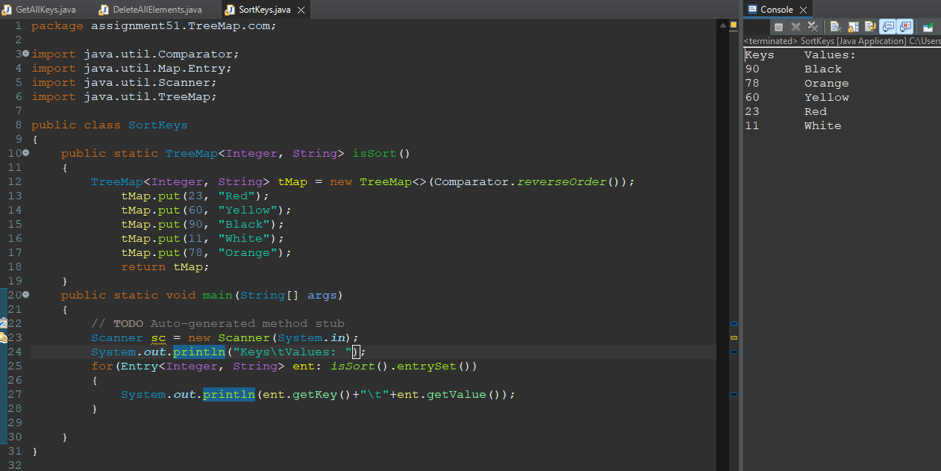

**8. Write a Java program to get a key-value mapping associated with the greatest key and the least key in a map.**

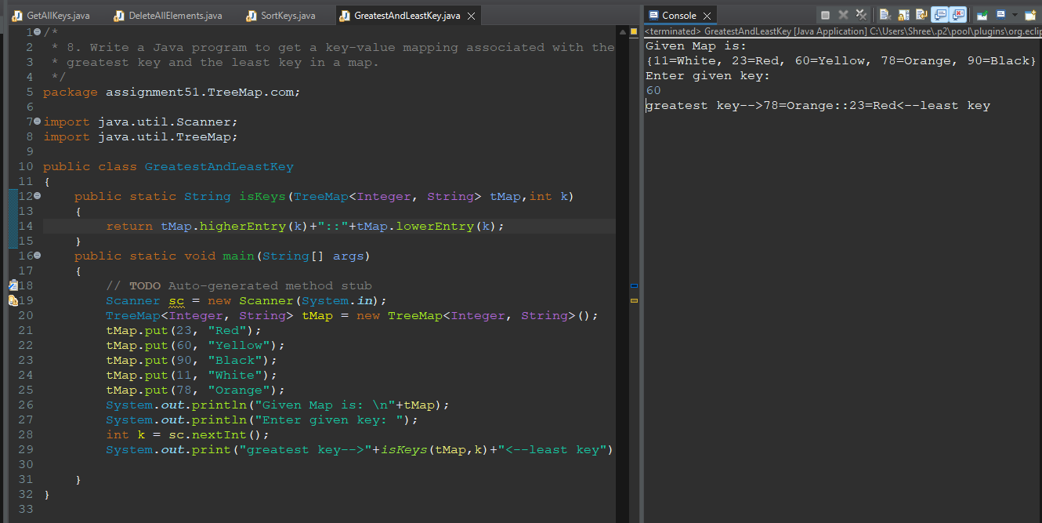

**9. Write a Java program to get the first (lowest) key and the last (highest) key currently in a map.**

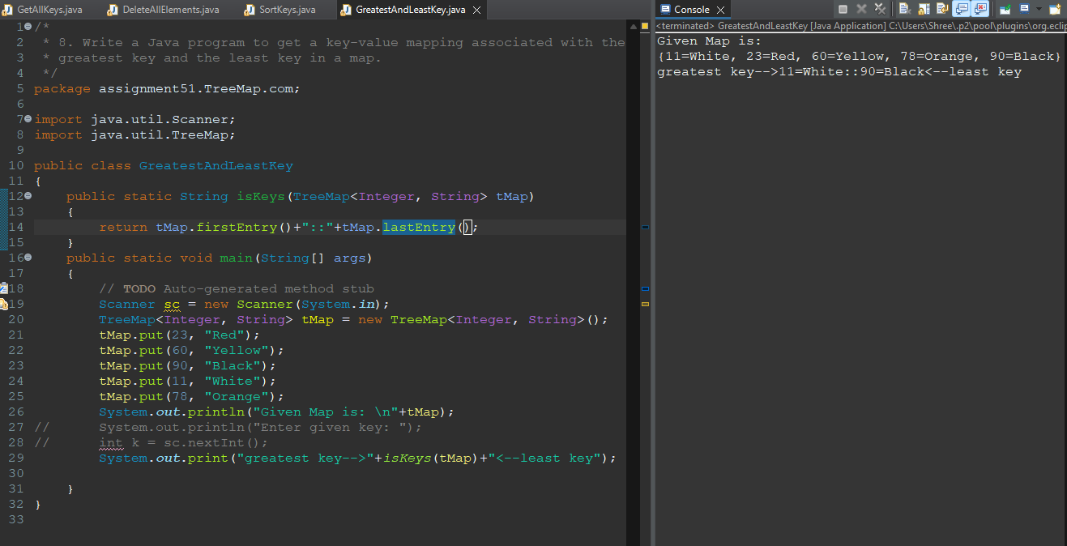

**10. Write a Java program to get a reverse order view of the keys contained in a given map.**



**11. Write a Java program to get a key-value mapping associated with the greatest key less than or equal to the given key.**

**12. Write a Java program to get the greatest key less than or equal to the given key.**

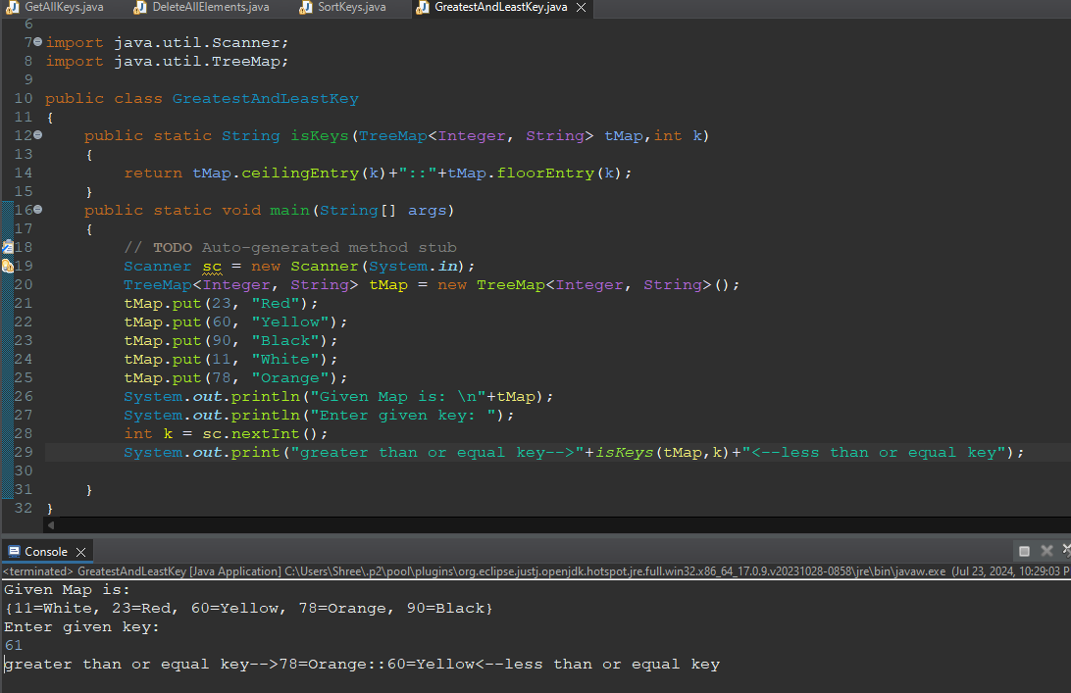

**13. Write a Java program to get the portion of a map whose keys are strictly less than a given key.**

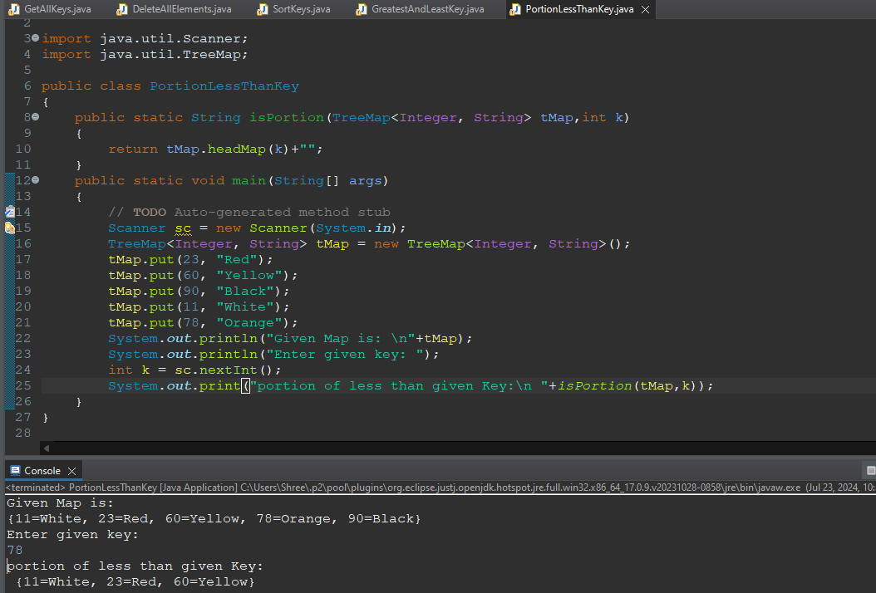

**14. Write a Java program to get the portion of this map whose keys are less than (or equal to, if inclusive is true) a given key.**

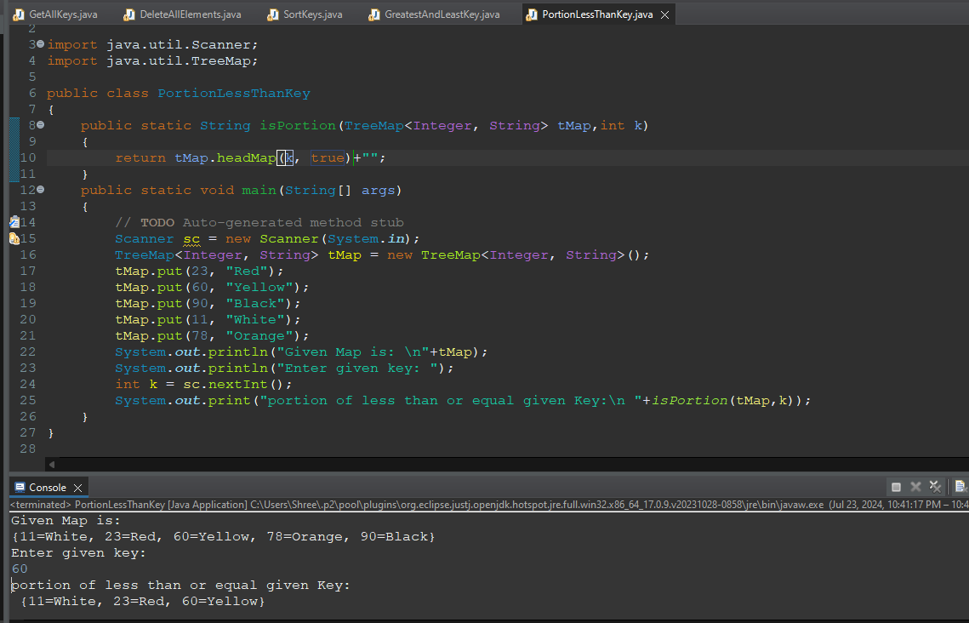

**15. Write a Java program to get the least key strictly greater than the given key. Return null if there is no such key.**

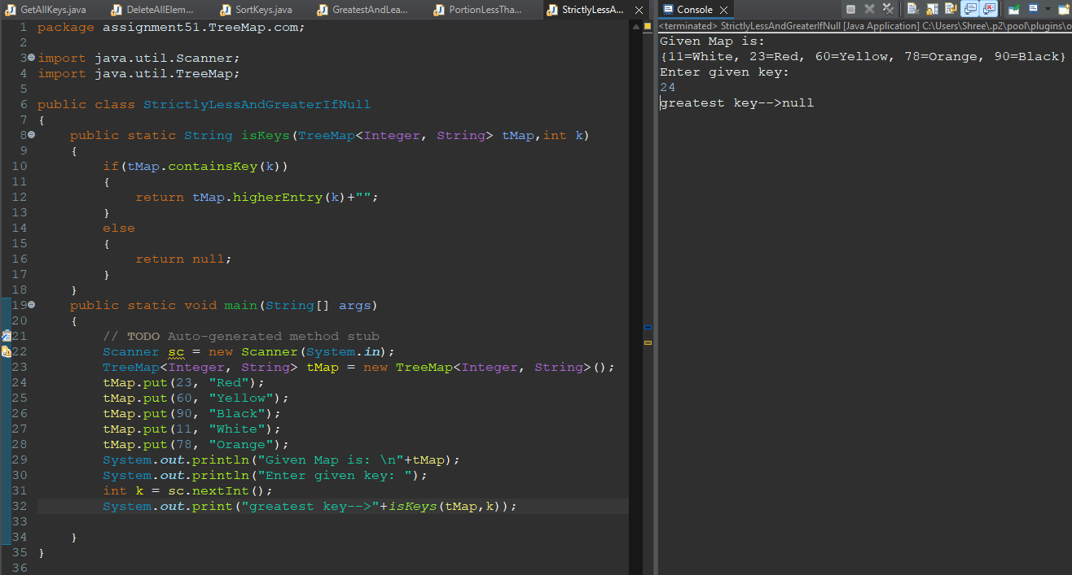

**16. Write a Java program to get a key-value mapping associated with the greatest key strictly less than the given key. Return null if there is no such key.**

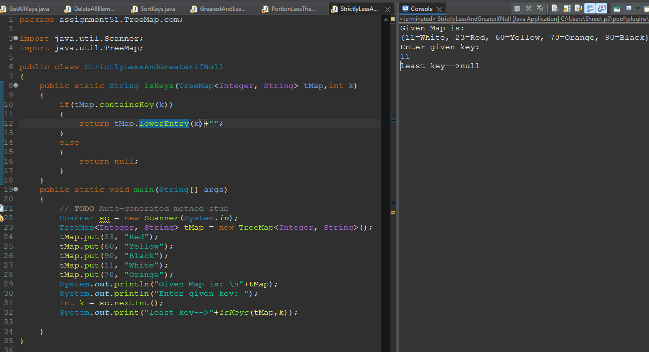

**17. Write a Java program to get the greatest key strictly less than the given key. Return null if there is no such key.**

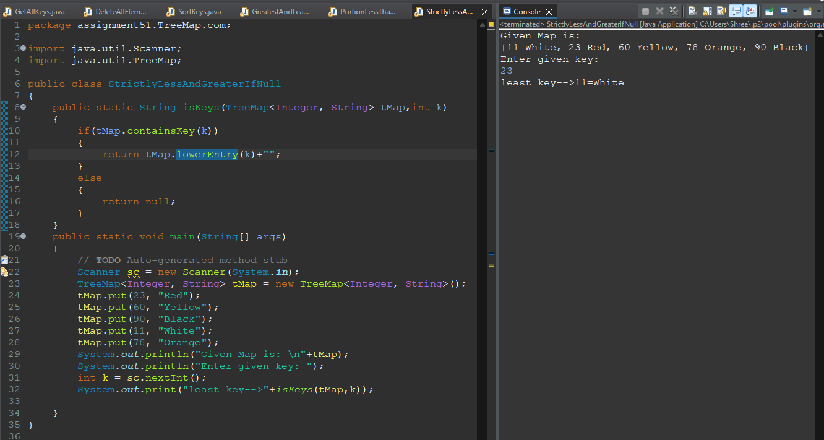

**18. Write a Java program to get a NavigableSet view of keys in a map.**

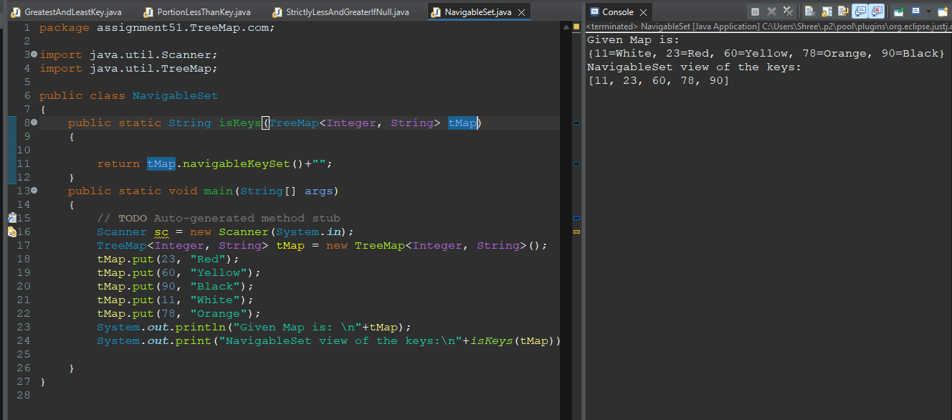

**19. Write a Java program to remove and get a key-value mapping associated with the least key in a map.**

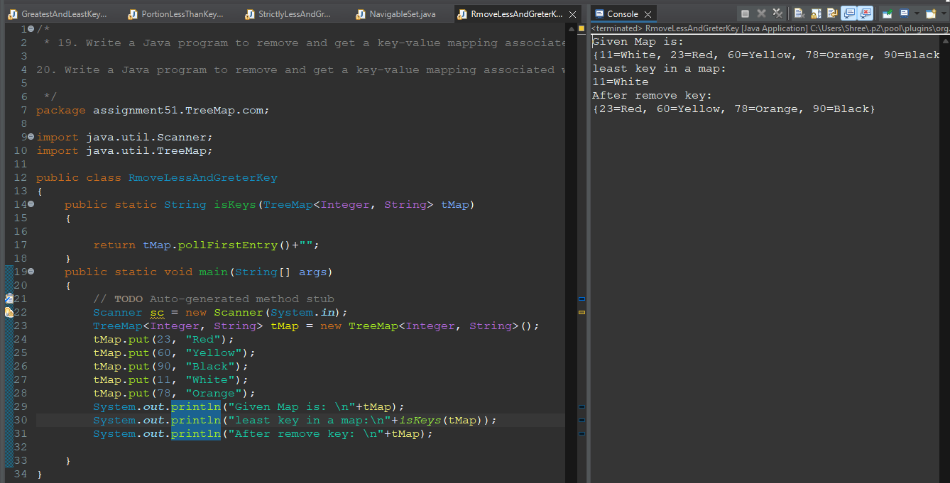

**20. Write a Java program to remove and get a key-value mapping associated with the greatest key in this map.**

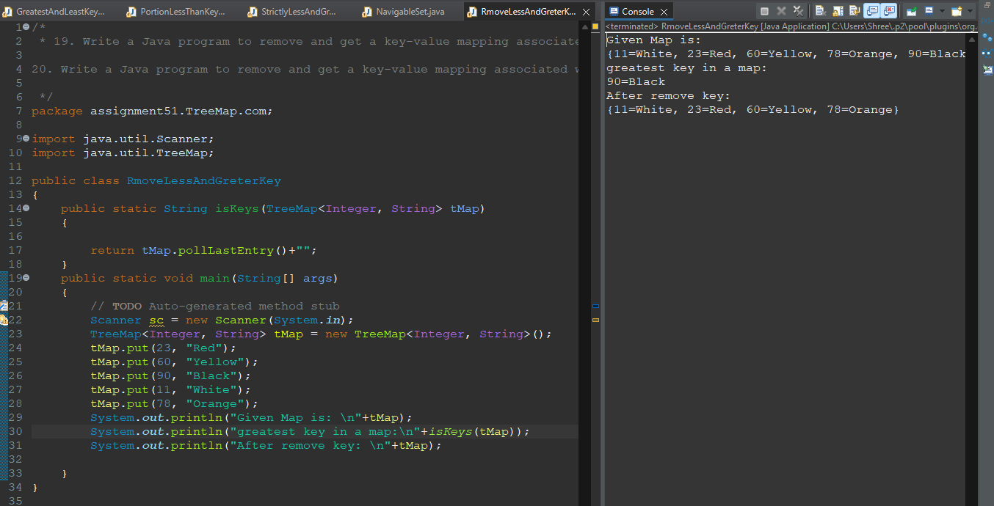

**21. Write a Java program to get the portion of a map whose keys range from a given key (inclusive) to another key (exclusive).**

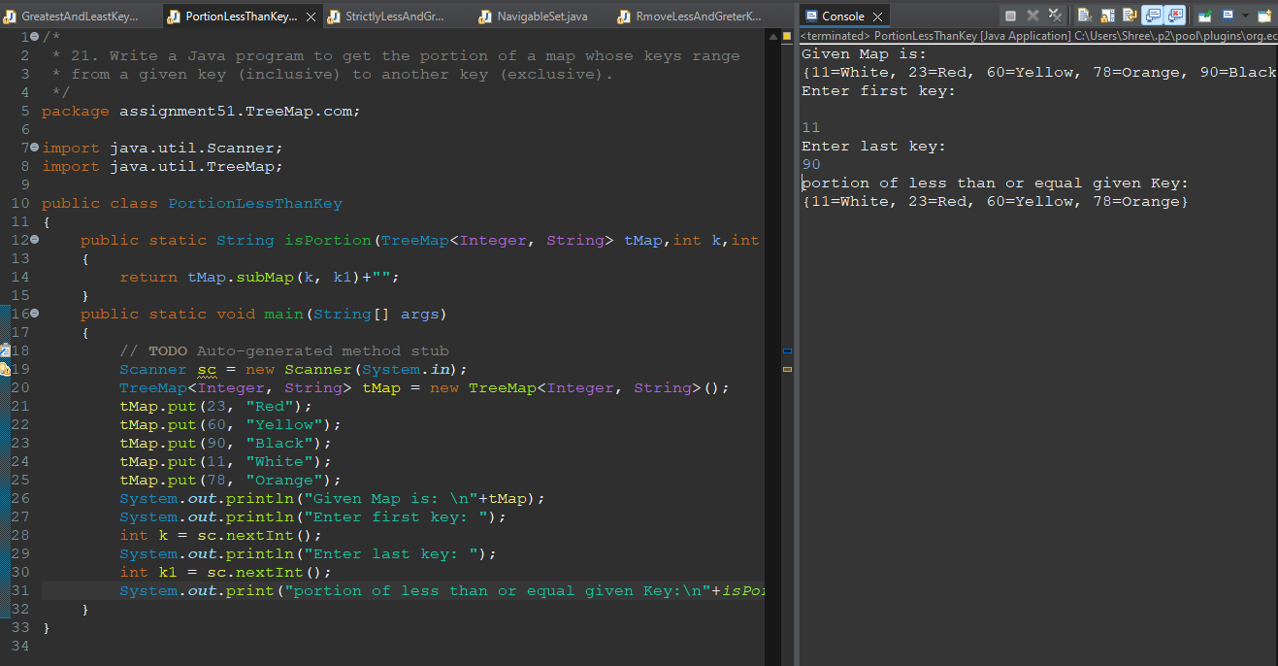

**22. Write a Java program to get the portion of a map whose keys range from a given key to another key.**

